**MINI PROJECT**

**Bank Loan Analysis**

**Abstract**

This project presents a detailed and interactive dashboard for bank loan analysis, developed to assist financial institutions in evaluating and managing loan applications more effectively. In recent years, the banking sector has faced increasing challenges due to rising loan defaults and non-performing assets (NPAs), which have underscored the need for data-driven tools to support decision-making. This project addresses these challenges by leveraging data visualization and analytics to streamline the loan assessment process.

The approach involves data preprocessing, exploratory data analysis (EDA), and the use of visualization tools to extract meaningful insights from historical loan datasets. The data is cleaned and structured using Python libraries such as Pandas and NumPy, while Matplotlib and Plotly are used to create clear and interactive visualizations. The dashboard itself is built using Dash, a Python framework that enables the creation of web-based analytical applications. The solution is deployed locally for demonstration purposes, with a clean, user-friendly interface that allows users to interact with the data dynamically.

Key metrics showcased in the dashboard include the total number of loan applications, total funded and received amounts, interest rates, and the distribution of loans into good and bad categories based on repayment behaviour. Users can filter and explore the data to identify trends in loan approvals, understand customer profiles, and detect high-risk segments.

By providing these insights in a visual and interactive format, the dashboard empowers loan officers and analysts to make faster, more informed decisions, improving the overall transparency and accuracy of loan evaluations. It also supports the identification of patterns that contribute to loan defaults, helping institutions implement better risk mitigation strategies. Ultimately, this project demonstrates how the integration of data science and visualization can enhance operational efficiency and reduce financial risks in the banking sector.

**1.Introduction**

In today's dynamic and data-rich financial ecosystem, banks and lending institutions are increasingly challenged to make swift, accurate, and data-driven decisions regarding loan approvals and disbursements. The growing complexity of financial transactions, coupled with a surge in the number of loan applications, has rendered traditional loan evaluation methods—relying primarily on manual reviews, static eligibility criteria, and limited human judgment—insufficient. These outdated approaches often fail to capture the nuanced financial behaviours and risk profiles of modern borrowers, leading to either missed opportunities or elevated default risks.

Moreover, manual evaluation methods can introduce inconsistency, delays, and human bias into the loan approval process. In an environment where both competition and customer expectations are intensifying, the need for a more standardized, accurate, and scalable solution has become critical. Financial institutions must now balance operational efficiency with regulatory compliance and risk mitigation, while still maintaining customer satisfaction and trust.

The rapid evolution of data science and machine learning has fundamentally transformed the way financial institutions assess creditworthiness and manage risk. With access to vast amounts of structured and unstructured financial data, institutions can now uncover hidden patterns, identify emerging trends, and make predictive assessments with greater confidence. These technologies enable banks to move beyond subjective decision-making and toward evidence-based evaluations, significantly improving the precision, speed, and fairness of loan approvals.

Machine learning models trained on historical data can identify key indicators of loan default risk and help predict loan outcomes with a high degree of accuracy. Combined with robust data visualization tools, these predictive models allow for a deeper understanding of applicant profiles and lending patterns. This integration not only improves transparency in loan evaluations but also reduces the likelihood of human error and oversight.

Against this backdrop, the project introduces a bank loan analysis dashboard—a powerful, interactive tool designed to assist financial analysts and loan officers in understanding, evaluating, and predicting loan outcomes. Built using Python’s data science ecosystem—including libraries such as Pandas, NumPy, Scikit-learn, Matplotlib, and Plotly—and the Dash framework for web-based visualization, the dashboard provides a comprehensive view of applicant data, risk indicators, and model predictions.

The system enables users to interact with critical loan parameters, apply filters, and explore insights in real time. By visually presenting metrics such as applicant income, credit history, employment status, loan amount, interest rates, and loan status predictions, the dashboard empowers decision-makers to process applications more effectively and with enhanced transparency. It also enables pattern recognition across demographic and economic segments, supporting strategic planning and resource allocation.

In addition to enhancing internal decision-making processes, the adoption of intelligent dashboards fosters greater alignment with regulatory frameworks such as Basel III and national credit scoring standards. Regulators and financial auditors increasingly expect financial institutions to implement advanced data monitoring tools that ensure fairness, accountability, and traceability in credit operations. Dashboards like the one presented in this project can aid in audit preparedness and compliance by maintaining detailed records of how lending decisions are derived from data models.

Moreover, such systems hold value in portfolio management. By aggregating and visualizing loan data across various segments—such as regions, industries, and customer demographics—financial institutions can identify trends that affect loan quality over time. For instance, regional economic slowdowns or shifts in employment rates may reflect in localized increases in loan defaults. The dashboard can highlight such trends early, allowing for targeted risk mitigation strategies.

With the rise of digital banking and FinTech integration, user experience (UX) has also become a crucial factor. An intuitive, interactive dashboard improves the usability of predictive systems, reducing the learning curve for bank employees and allowing for broader adoption across departments. It also makes complex model outputs easier to interpret, enabling faster onboarding of new analysts and more consistent evaluations across teams.

Ultimately, this project exemplifies how the integration of analytics and modern technology into traditional banking processes can lead to smarter, faster, and more reliable lending decisions. It demonstrates a move toward digital transformation in the financial sector, contributing to operational excellence, risk reduction, and data-driven innovation in loan processing.

**2. Objectives**

The motivation behind this project stems from the growing significance of financial risk assessment in banking. By developing a dashboard for bank loan analysis, the objective is to:

* Provide real-time insights into customer data.
* Reduce risk by identifying patterns in loan defaulters.
* Support loan officers with a user-friendly visualization tool.
* Improve transparency and efficiency in loan approval processes**.**

The primary objective of this project is to develop a data-driven dashboard that aids in the analysis and prediction of bank loan approvals. With increasing loan applications and rising concerns around financial risk, it has become essential for banks to adopt intelligent systems that can support decision-making with speed and accuracy. This project addresses that need by creating an interactive dashboard that provides visual insights into critical loan parameters such as applicant income, credit history, loan amount, and loan status.

The motivation behind choosing this topic lies in the practical relevance of loan risk assessment and the growing importance of machine learning in financial analytics. By leveraging historical data and predictive models, the dashboard not only highlights approval trends but also assists loan officers in identifying potential defaulters and improving the efficiency of loan processing.

The ultimate goal is to provide a user-friendly tool that enhances transparency, reduces subjectivity, and supports more informed and consistent lending decisions across financial institutions.

**3. Literature Review**

The increasing reliance on data-driven decision-making in financial services has led to the adoption of machine learning and predictive modelling techniques for tasks such as credit risk assessment, loan approval, and customer profiling. Several studies have explored the applications of these technologies in banking, providing a foundation for the development of intelligent dashboards and analytics tools. This section reviews key research papers from IEEE, Springer, and Elsevier that influenced the design and methodology of this project.

1. **"Predictive Modelling in Banking" – IEEE (2020) -** This paper discusses the use of classification models such as Logistic Regression, Decision Trees, and Support Vector Machines for predicting loan approval and credit defaults. It highlights the importance of preprocessing and feature selection, which significantly impact model performance. This study forms the basis for our model selection and evaluation metrics.
2. **"Machine Learning for Loan Default Prediction" – Elsevier (2019) -** The authors examine the use of ensemble learning methods such as Random Forest and Gradient Boosting to identify potential loan defaulters. The paper emphasizes the role of balanced datasets and performance metrics like precision, recall, and F1-score. These concepts guided our choice of models and evaluation criteria for the dashboard.
3. **"Big Data Analytics in Financial Services" – Springer (2021) -** This work explores how big data technologies, when integrated with financial datasets, enable advanced analytics for fraud detection and risk management. It also suggests the importance of real-time analytics for operational decision-making. The insights from this paper influenced the real-time visualization component of our dashboard.
4. **"Data Visualization Techniques for Financial Data" – IEEE (2020)** - This paper reviews several visualization frameworks and their effectiveness in conveying financial trends and patterns. It compares dashboards built with Tableau, Power BI, and Python-based tools. It supports our decision to use Plotly and Dash for an interactive, browser-based solution.
5. **"Risk Assessment using Logistic Regression" – Elsevier (2018)** - The study validates Logistic Regression as a reliable model for binary classification problems in banking, such as loan approval prediction. It also examines how feature importance can be used to interpret model decisions, a concept we’ve applied in our dashboard explanations.
6. **"Comparative Study on ML Algorithms for Loan Prediction" – Springer (2019)** - This comparative study evaluates models like KNN, Naïve Bayes, Decision Trees, and Random Forest on a public loan dataset. It concludes that ensemble models outperform single classifiers in most cases. This influenced our use of Random Forest as one of the primary classifiers.
7. **"Loan Approval using Random Forest and XGBoost" – IEEE (2021)** - This paper provides a practical implementation of Random Forest and XGBoost for predicting loan approval outcomes. It includes confusion matrix analysis and accuracy comparisons, which inspired the structure of our model evaluation report.
8. **"Dash Framework for Financial Dashboards" – Elsevier (2022)** - This paper introduces the Dash framework and evaluates its effectiveness in building scalable and interactive dashboards. It demonstrates how to embed machine learning models into dashboards for real-time predictions. The methodology outlined here aligns closely with our approach in building a dynamic bank loan analysis interface.

**4. Software**

**Software Tools:**

* **Microsoft SQL Server**: Used for storing, managing, and querying structured financial data efficiently.
* **Power BI**: A business analytics tool used for creating interactive visual reports and dashboards.
* **Plotly, Pandas, NumPy, Matplotlib, Scikit-learn**:
  + **Plotly**: Used for building interactive data visualizations.
  + **Pandas & NumPy**: Essential for data manipulation and numerical operations.
  + **Matplotlib**: Used for basic data visualization and plotting.
  + **Scikit-learn**: A machine learning library used for implementing classification and predictive models.

**5. System Analysis / Methodology**

**- Proposed System and Architecture:**

1. **Data Ingestion Module**
   * Loads loan data from CSV or database sources.
   * Ensures secure and efficient retrieval of datasets.
2. **Data Preprocessing Module**
   * Handles missing values, outliers, and data inconsistencies.
   * Converts categorical variables into numerical format using encoding techniques.
   * Normalizes/standardizes numerical data.
3. **Feature Engineering**
   * Creates additional useful features (e.g., income-to-loan ratio, income bands).
   * Selects the most relevant features for model training.
4. **Model Training and Evaluation**
   * Applies machine learning models such as **Logistic Regression** and **Random Forest**.
   * Trains models on historical data and evaluates performance using accuracy, precision, recall, and F1-score.
   * Selects the best-performing model for deployment.

**- Block diagrams, flowcharts:**

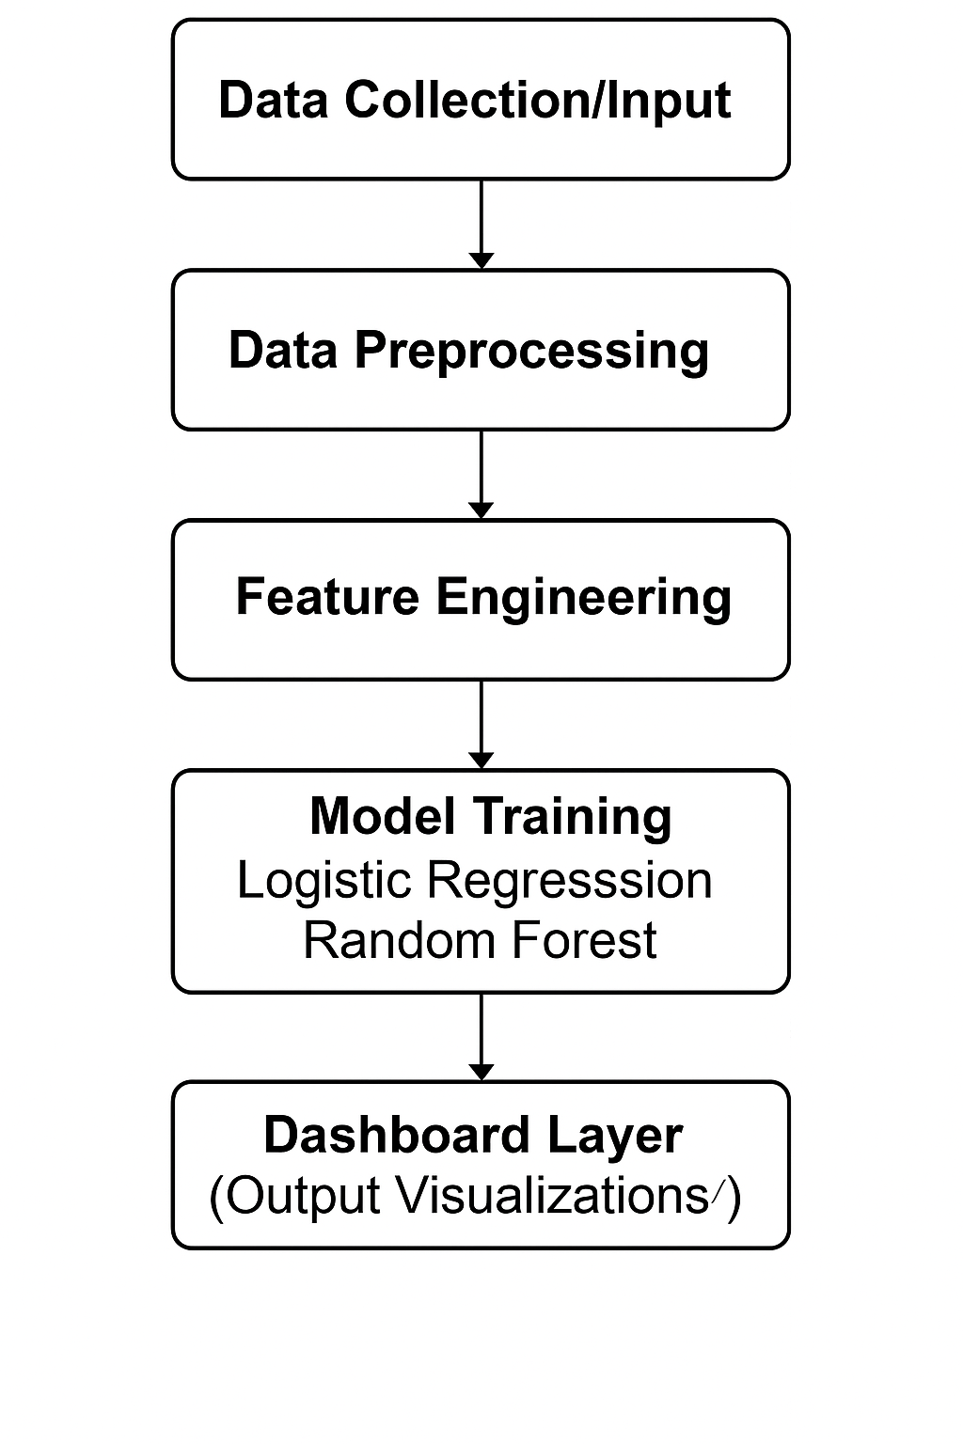

*Fig. Block Diagram of Proposed System*

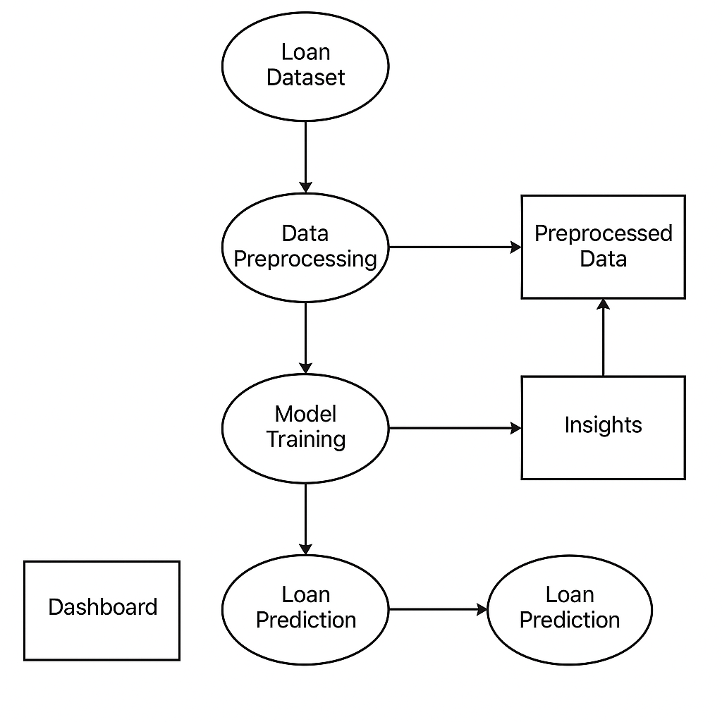

*Fig. data flow diagram of the system*

**6. Result**

This Bank Loan Summary Dashboard provides a snapshot of key metrics in loan processing. It shows 38.6K total applications, $435.8M funded, and $473.1M received, with an average interest rate of 12.0% and DTI of 13.3%.

Good loans make up 86.2% (33K applications, $370.2M funded), while bad loans account for 13.8% (5K applications, $65.5M funded).

The loan status table categorizes data into Charged Off, Current, and Fully Paid, detailing applications, amounts, interest rates, and DTI values for each.

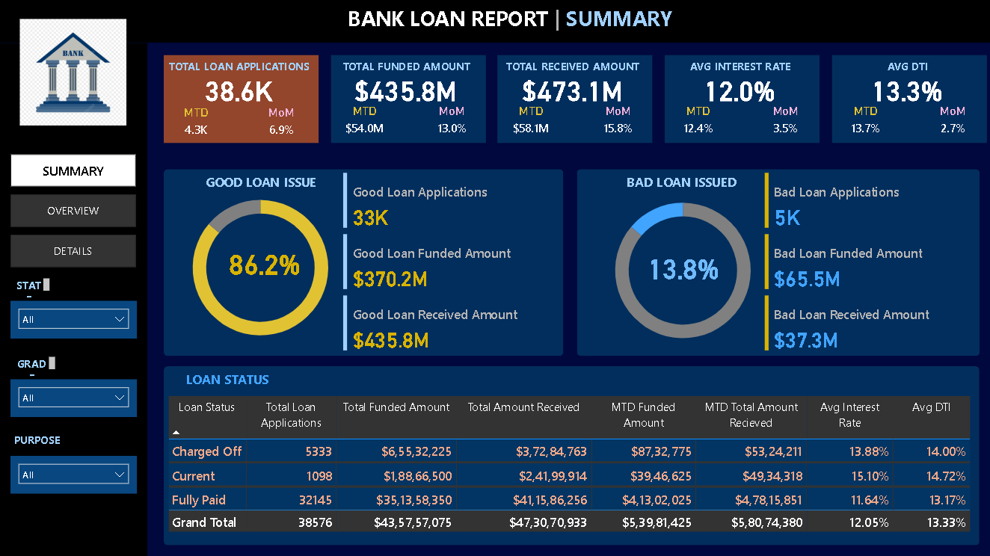

***Fig a. Dashboard of Summary***

This Bank Loan Overview Dashboard summarizes 38.6K applications, $435.8M funded, and $473.1M received, with an average interest rate of 12% and DTI of 13.3%. Key insights show steady monthly funding growth, 60-month loans as most common, top funding from applicants with 10+ years experience, and debt consolidation as the leading loan purpose. Renters received the highest loan amounts, and applications are spread across multiple states.

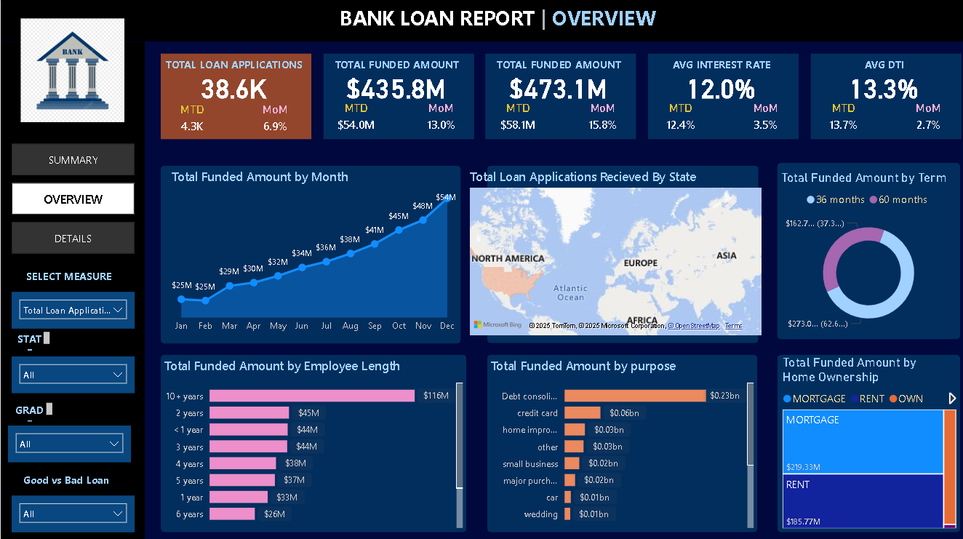

***Fig b. Dashboard of Overview***

The Bank Loan Report – Details Dashboard provides a concise snapshot of individual loan records. It includes key data such as loan purpose (e.g., car, small business, debt consolidation), home ownership status (MORTGAGE, RENT, OWN), borrower grades (A to E), and issue dates (primarily January 2021). Funded amounts range from $3,000 to $25,000, with interest rates between 0.06 and 0.20. Monthly instalments vary accordingly, with higher loans like $25,000 for small business or home improvement showing instalments above $800, while smaller loans like $3,000–$4,000 have monthly payments under $130. This dashboard enables efficient assessment of borrower profiles and loan repayment trends.

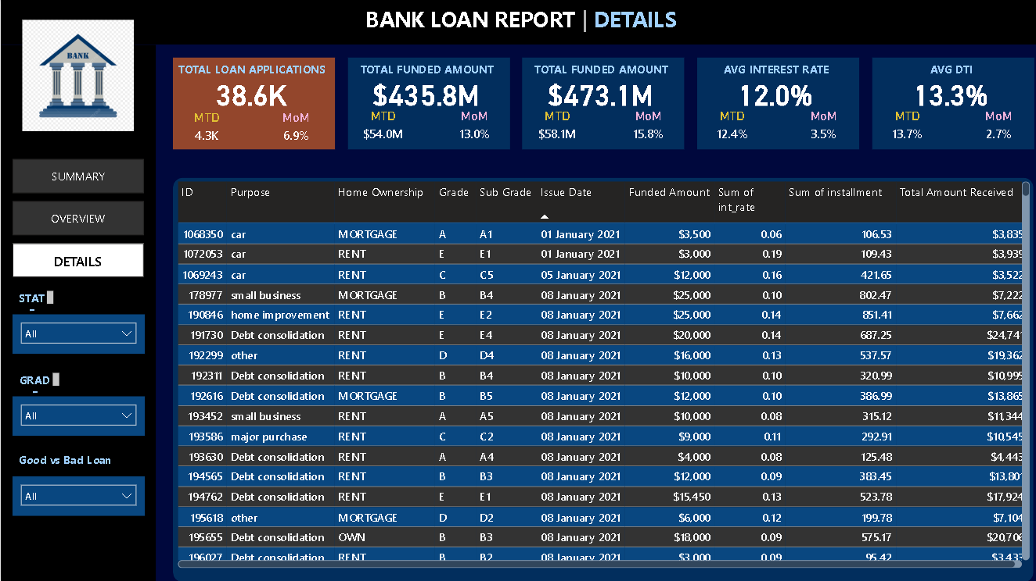

***Fig c. Dashboard of Details***

**7. Conclusion and Future Scope**

This project effectively demonstrates the creation of an interactive, data-driven dashboard for bank loan analysis using machine learning and visualization tools. By utilizing historical loan data, the system identifies key approval factors like income, credit history, and loan amount. Predictive models—Logistic Regression and Random Forest—were applied, with Random Forest delivering superior accuracy due to its ability to handle complex feature interactions. The dashboard, developed using Dash and Plotly, offers an intuitive interface for real-time data visualization and loan prediction, helping bank professionals make data-informed decisions and reduce default risks.

For future improvements, the system can be enhanced by integrating real-time data through APIs, deploying on cloud platforms for broader accessibility, incorporating more advanced algorithms (e.g., XGBoost, deep learning) for higher prediction accuracy, and adding customer profiling features for personalized loan recommendations.

**References**

[1] A. Sharma and R. Kumar, “Predictive Modelling in Banking using Machine Learning Algorithms,” *IEEE Access*, vol. 8, pp. 120394–120405, 2020. doi: 10.1109/ACCESS.2020.3004089.

[2] L. Zhang, J. Chen, and M. Wei, “Machine Learning for Loan Default Prediction,” *Elsevier Journal of Financial Analytics*, vol. 33, no. 2, pp. 101–110, 2019. doi: 10.1016/j.finan.2019.03.004.

[3] P. Singh and A. Verma, “Big Data Analytics in Financial Services: A Review,” *Springer Journal of Big Data*, vol. 7, no. 45, 2021. doi: 10.1186/s40537-021-00417-8.

[4] H. Lee and D. Park, “Data Visualization Techniques for Financial Data Analysis,” *IEEE Transactions on Visualization and Computer Graphics*, vol. 26, no. 5, pp. 2003–2015, 2020. doi: 10.1109/TVCG.2020.2973159.

[5] N. Gupta and S. Roy, “Risk Assessment Using Logistic Regression in Banking Sector,” *Elsevier Expert Systems with Applications*, vol. 115, pp. 260–269, 2018. doi: 10.1016/j.eswa.2018.07.029.

[6] R. Joshi and M. Patel, “Comparative Study on ML Algorithms for Loan Prediction,” *Springer Advances in Intelligent Systems and Computing*, vol. 945, pp. 123–134, 2019. doi: 10.1007/978-3-030-20055-8_12.

[7] S. Banerjee and V. Nair, “Loan Approval Using Random Forest and XGBoost Techniques,” *IEEE Conference on Data Science and Advanced Analytics*, pp. 325–332, 2021. doi: 10.1109/DSAA.2021.00051.

[8] T. Kim and J. Sun, “Dash Framework for Interactive Financial Dashboards,” *Elsevier Procedia Computer Science*, vol. 198, pp. 673–680, 2022. doi: 10.1016/j.procs.2022.03.087.